KLE TECHNOLOGICAL UNIVERSITY, HUBBALLI.
DEPARTMENT OF BACHELOR IN COMPUTER APPLICATION
KLE Society's

A Project SRS document
Vehicle Parking Permit Registration
Submitted in partial fulfilment of the requirement for degree
BACHELOR OF COMPUTER APPLICATION
Submitted by:
[Manikant K ] – [01FE24BCA264]
[Sumit H] – [01FE24BCA273]
[Raghav H] – [01FE24BCA267]
[Prashant G] – [01FE24BCA302]
Under the Guidance of
Prof. Pavan Vadavi
Prof. Sayeeda Anjum

1. Introduction
Educational campuses, residential societies, offices and public premises have a limited number of parking spaces. To control who may park and where, vehicles are usually required to hold a parking permit. When permit applications, approvals and renewals are handled on paper or in registers, it becomes difficult to verify whether a vehicle is registered, to know how many permits are active in a zone, and to find out which permits have expired.
The proposed project, Vehicle Parking Permit Registration, provides a web-based system for registering vehicle owners and their vehicles, applying for a parking permit in a chosen parking zone, reviewing the application, issuing the permit and tracking its status until it expires, is renewed or is revoked. The system checks every application against defined rules, such as one active permit per vehicle and the available capacity of the parking zone, and rejects applications that break these rules.
The system offers a simple web interface for managing owner, vehicle and parking zone details, submitting and reviewing permit applications, searching permit records and generating basic reports. It applies foundational concepts from Database Management Systems (DBMS), Object-Oriented Programming (OOP), Web Technologies, Data Structures and Programming, and Software Engineering to develop a manageable and maintainable system.

1.1 Purpose
The purpose of this project is to develop a web-based system that manages the registration of vehicles for parking permits efficiently. The system maintains owner, vehicle and permit records, validates permit applications, supports approval, renewal and revocation, and shows the current status of every permit. It aims to reduce paperwork and record-keeping errors, prevent duplicate or unauthorised permits, and provide reliable information about permit validity and parking zone usage.

1.2 Scope
The project focuses on the basic operations required for vehicle parking permit registration. Its main features include:
- Maintaining owner, vehicle and parking zone details.
- Submitting permit applications for a registered vehicle and a parking zone.
- Validating applications against the defined business rules.
- Reviewing applications, and issuing, renewing or revoking permits.
- Deriving and displaying the current status of each permit (Pending, Active, Rejected, Expired or Revoked).
- Maintaining permit history for tracking and verification.
- Providing basic reports on applications, active permits and parking zone occupancy.

1.3 Objectives
The main objectives of the project are:
- To maintain owner, vehicle and parking zone information systematically.
- To allow vehicle owners to apply for and renew parking permits online.
- To validate applications and prevent duplicate permits and over-allocation of parking zones.
- To allow the administrator to review, approve, reject and revoke permits.
- To derive the current status of each permit from its dates and decisions, so that expired permits are identified correctly.
- To maintain permit history for tracking and verification.
- To apply foundational concepts of DBMS, OOP, Web Technologies and Software Engineering in developing a reliable system.

1.4 Intended Audience
This document is intended for project guides, faculty members, evaluators, developers and students who want to understand the requirements and functionality of the proposed system. It describes the purpose, scope, features, constraints and technical requirements of the Vehicle Parking Permit Registration system. It can also be used as a reference during system design, development, testing and maintenance.

1.5 Document Overview
This Software Requirements Specification (SRS) describes the requirements of the Vehicle Parking Permit Registration system. It includes the project introduction, purpose, scope, objectives, functional and non-functional requirements, business rules, system constraints, hardware and software requirements, system design diagrams (architecture, ER, UML and data flow diagrams), possible future enhancements, conclusion and references. This document provides a clear understanding of the system's expected behaviour and serves as a guide throughout the software development process.

1.6 Foundational Concepts Used
The project applies the following foundational concepts:
- Database Management Systems (DBMS): Used to store and manage owner, vehicle, parking zone and permit records systematically.
- Data Structures and Programming: Used to organise records and implement the logic required to validate applications and determine permit status.
- Object-Oriented Programming (OOP): Used to organise the application into classes and objects, improving code reusability and maintainability.
- Web Technologies: Used to develop the user interface and enable users to interact with the system through web pages.
- Software Engineering and SDLC: Used to follow a systematic development process involving requirement analysis, design, implementation, testing and maintenance.
- Data Validation and Integrity: Used to ensure that applications follow the defined business rules and that permit records remain consistent.

2. Specific Requirements
This section describes the functional and operational requirements of the Vehicle Parking Permit Registration system. It specifies the main features and operations that the system must support for registering vehicles and managing parking permits.

2.1 Functional Requirements
Functional requirements describe the operations that the system must perform.
Requirement ID | Functional Requirement | Description
FR-01 | Manage Owner Details | The system shall allow a vehicle owner or the administrator to add, view, search and update owner details, including owner ID, name, phone number, email and address.
FR-02 | Manage Vehicle Details | The system shall allow an owner or the administrator to add, view, search and update vehicle details, including vehicle ID, registration number, vehicle type, model and the owner it belongs to.
FR-03 | Manage Parking Zones | The system shall allow the administrator to add, view and update parking zones, including zone ID, name, location, capacity and permit fee.
FR-04 | Submit Permit Application | The system shall allow an owner to submit a permit application by selecting a registered vehicle and a parking zone. A unique permit ID and application date shall be recorded.
FR-05 | Validate Applications | The system shall validate required fields, the existence of the vehicle and zone, the absence of an active permit for the same vehicle and the availability of zone capacity before accepting an application.
FR-06 | Reject Invalid Applications | The system shall reject incomplete, duplicate or rule-breaking applications and display a suitable error message.
FR-07 | Review Application | The system shall allow the administrator to view pending applications and approve or reject each of them, with remarks.
FR-08 | Issue Permit | The system shall issue a permit on approval by setting its status to Active and recording the issue date and expiry date.
FR-09 | Renew Permit | The system shall allow an owner to apply for renewal of an Active or Expired permit, which is processed in the same way as a new application.
FR-10 | Revoke Permit | The system shall allow the administrator to revoke an Active permit by recording the reason, after which the permit is no longer valid.
FR-11 | Derive Permit Status | The system shall determine the current status of each permit (Pending, Active, Rejected, Expired or Revoked) from its decision and expiry date and display it to the user.
FR-12 | View and Search Permit Records | The system shall allow users to view permit records and the administrator to search them using details such as permit ID, vehicle registration number, owner, zone, status or date.
FR-13 | Generate Basic Reports | The system shall provide basic reports showing pending applications, active permits, expired permits and parking zone occupancy.
FR-14 | Maintain Traceability | The system shall record the date and time of every application and decision and the identifier of the person who made it. Accepted permit records shall be protected from direct modification or deletion.

2.2 Non-Functional Requirements
Non-Functional Requirement | Description
Performance | The system shall respond to user requests, such as searching for permits and viewing permit status, within a reasonable time.
Reliability | The system shall maintain accurate owner, vehicle and permit records and provide consistent permit status information.
Usability | The system shall provide a simple and user-friendly interface that allows owners and administrators to perform operations easily.
Data Integrity | The system shall maintain consistent records by validating inputs and preventing duplicate registration numbers, duplicate permit IDs and invalid operations.
Security | The system shall restrict database access to the application, separate owner and administrator functions, and handle user inputs carefully to reduce the risk of unauthorised access and invalid data entry.
Maintainability | The system shall be designed using modular code so that individual components can be tested, corrected and modified easily.
Portability | The system shall be capable of running on commonly used operating systems with a compatible web browser and database setup.
Accuracy | The system shall derive permit status from the recorded decision and expiry date to minimise errors in the displayed status.

2.3 Business Rules and System Constraints
- Each owner, vehicle, parking zone and permit shall have a unique identifier.
- A vehicle registration number shall be unique and a vehicle shall belong to exactly one owner.
- A vehicle shall have only one Active permit at any time.
- A permit shall be issued only if the selected parking zone has free capacity.
- A permit shall be valid from its issue date up to its expiry date. After the expiry date its status shall be Expired and it shall not be valid for parking.
- A Revoked or Rejected permit shall record the reason in its remarks.
- Invalid, duplicate or rule-breaking applications shall be rejected and shall not be stored as permits.
- The system shall use Python, Flask, MySQL, HTML, CSS and JavaScript.
- The system shall require a compatible Python environment, a MySQL database and a web browser to operate.

3. Hardware and Software Requirements
This section describes the basic hardware and software needed to develop and run the proposed system.

3.1 Hardware Requirements
- Computer or laptop capable of running a web browser, Python development tools and MySQL.
- Minimum 4 GB RAM recommended; 8 GB is preferable for smoother development.
- Sufficient disk space for Python, VS Code, MySQL, required libraries and project files.
- A processor capable of running the required development tools and database software.

3.2 Software Requirements
- Operating System: Windows.
- Programming Language: Python.
- Frontend/Web Technologies: HTML5, CSS3 and JavaScript.
- Backend Framework: Flask.
- Database: MySQL.
- Database Connectivity: MySQL Connector for Python.
- Database Tool: MySQL Workbench.
- Development Tool: Visual Studio Code (VS Code).
- Web Browser: Google Chrome or Microsoft Edge.

Purpose of the Technologies
- Python is used to implement the application logic.
- Flask is used to handle web requests and connect the user interface with the application logic.
- HTML, CSS and JavaScript are used to develop the web pages and user interactions.
- MySQL is used to store owner, vehicle, parking zone and permit records.
- MySQL Connector/Python is used to connect the Flask application with the MySQL database.
- VS Code is used for writing and managing the project code, and MySQL Workbench is used to design and inspect the database tables.

4. System Design

4.1 System Architecture
The system follows a layered architecture. Owners and administrators use a web browser (presentation layer) to send requests to the Flask application (application layer), which validates the data, applies the business rules and reads or writes records in the MySQL database through MySQL Connector/Python (data access layer). The result is returned to the browser as a confirmation or rejection message, the current permit status, permit details or reports.
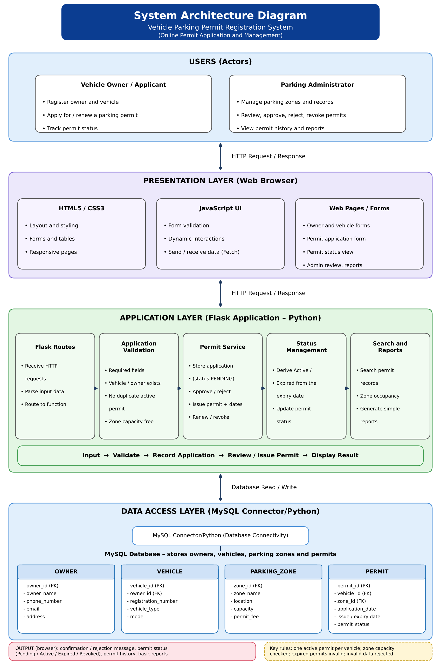

4.2 ER Diagram
The Entity Relationship Diagram represents the database structure of the system.

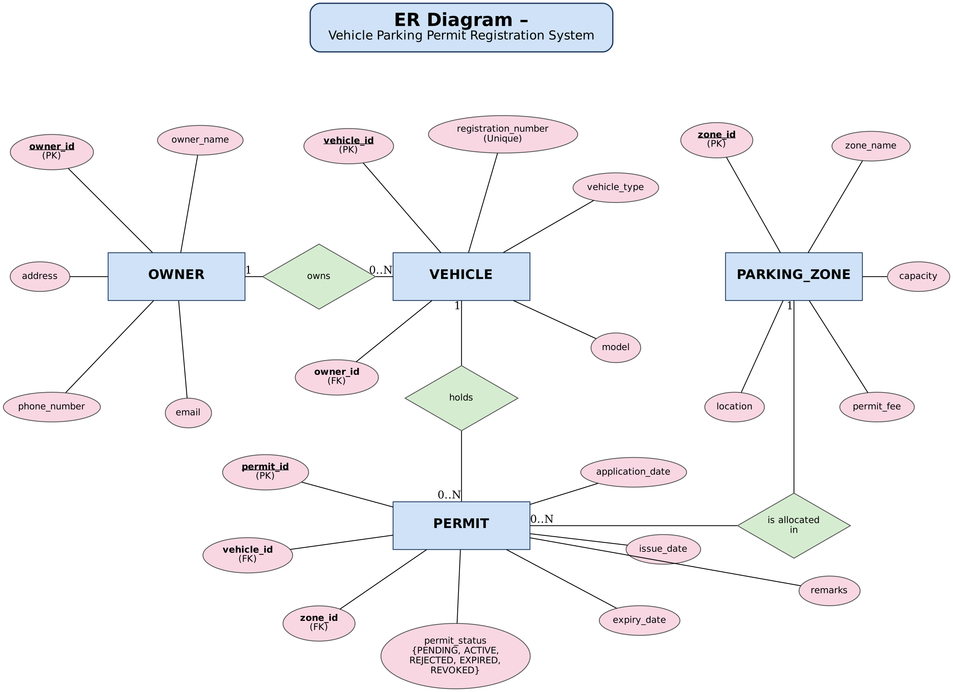

The Owner entity stores the personal details of each vehicle owner. The Vehicle entity stores the details of each vehicle and refers to its owner. The Parking_Zone entity stores the parking areas with their capacity and fee. The Permit entity stores each permit application and the resulting permit, together with its dates and status.
Each vehicle is associated with an owner through the owner_id foreign key, and each permit is associated with a vehicle and a parking zone through the vehicle_id and zone_id foreign keys. Primary keys uniquely identify records, while foreign keys maintain relationships between the tables. Database constraints, such as the unique registration number, help prevent duplicate and inconsistent reco

4.3 UML Diagrams
Unified Modeling Language (UML) diagrams are used to represent the structure and behaviour of the proposed system.
The Use-case Diagram shows the operations performed by the vehicle owner and the parking administrator.
The Activity Diagram represents the step-by-step flow of a permit application, including validation, rejection of invalid applications, review and issue of the permit.
The Sequence Diagram shows how the user interface, application logic, validation module and database interact during application processing and review.
The Class Diagram represents the main classes, their attributes, methods and relationships.
The State Diagram represents the possible states of a permit (Pending, Active, Rejected, Expired and Revoked) and the transitions between them.

1. Activity Diagram
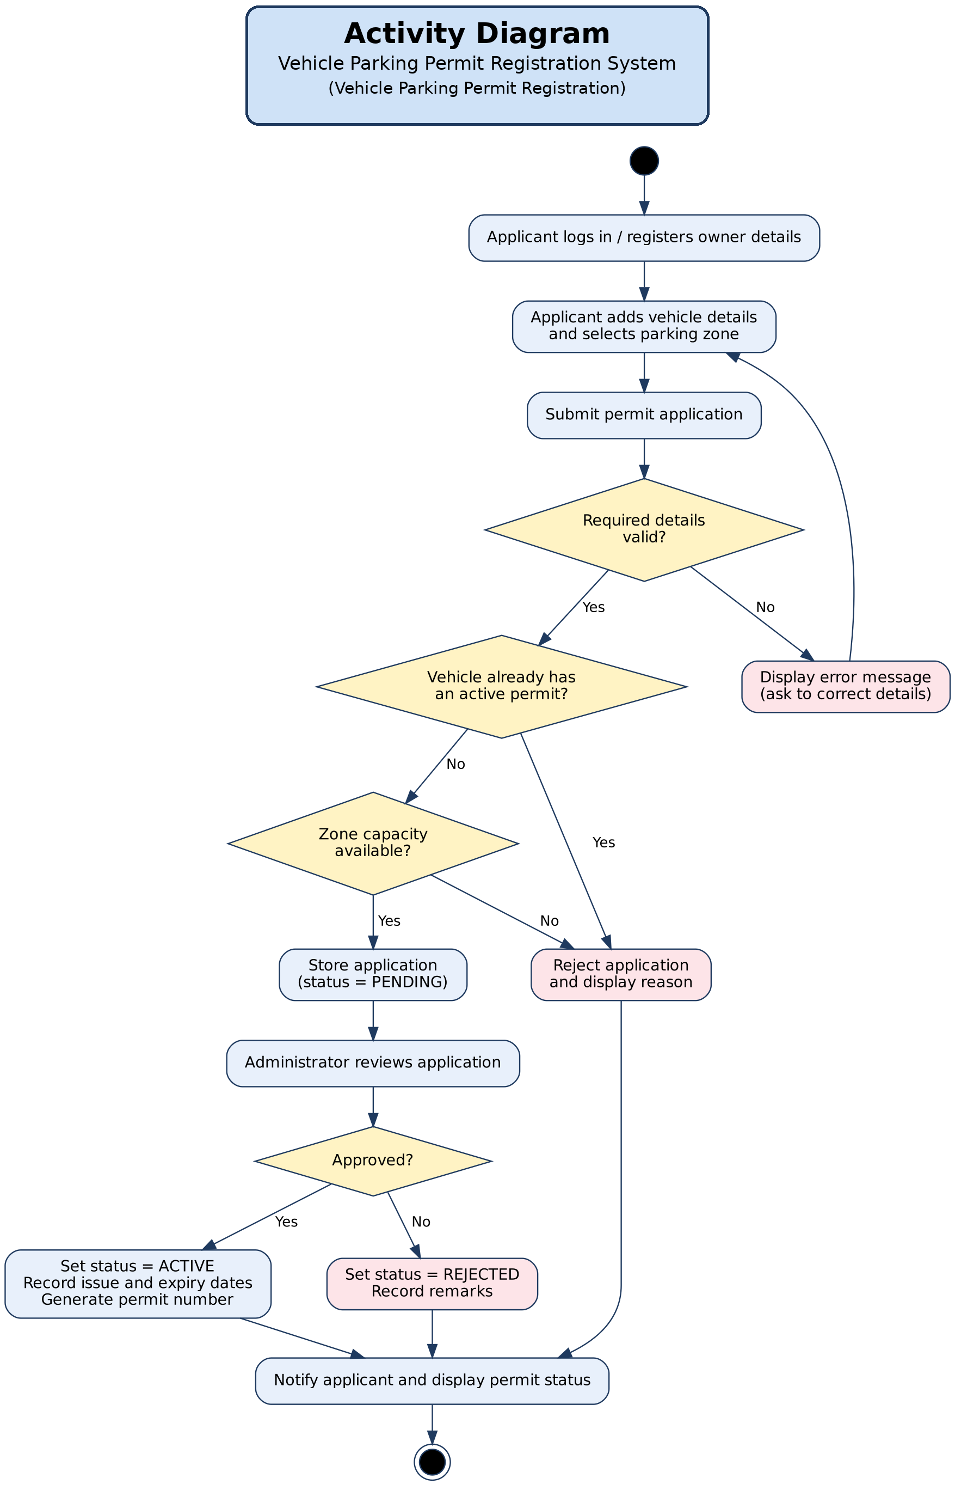

2. Use-case Diagram
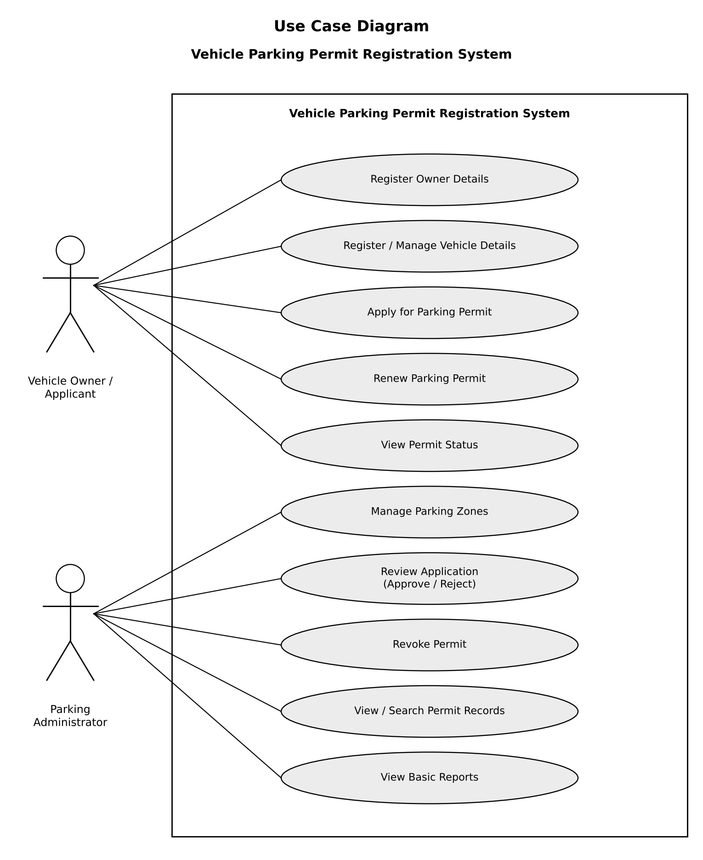

3. Sequence Diagram
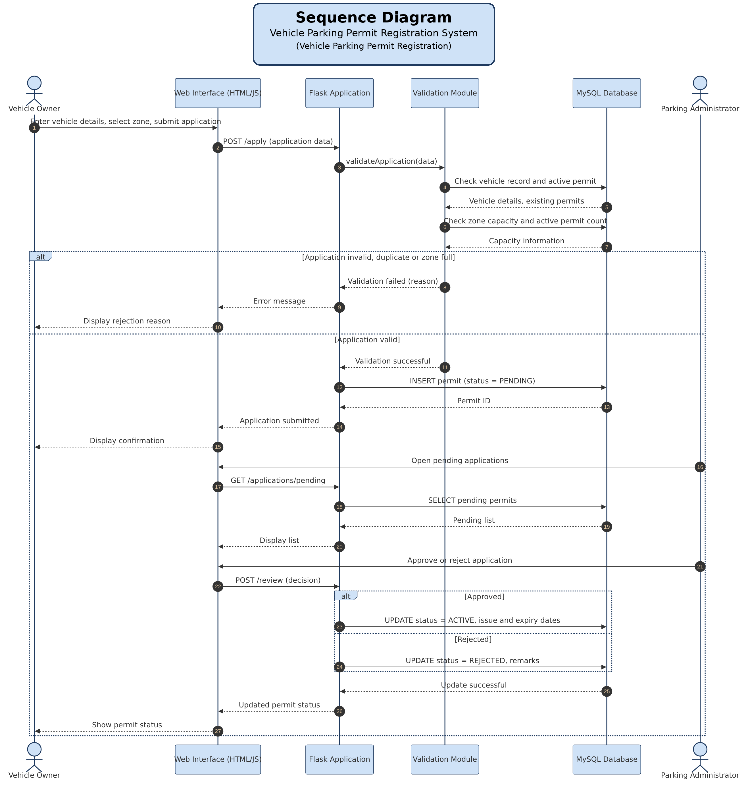

4. Class Diagram
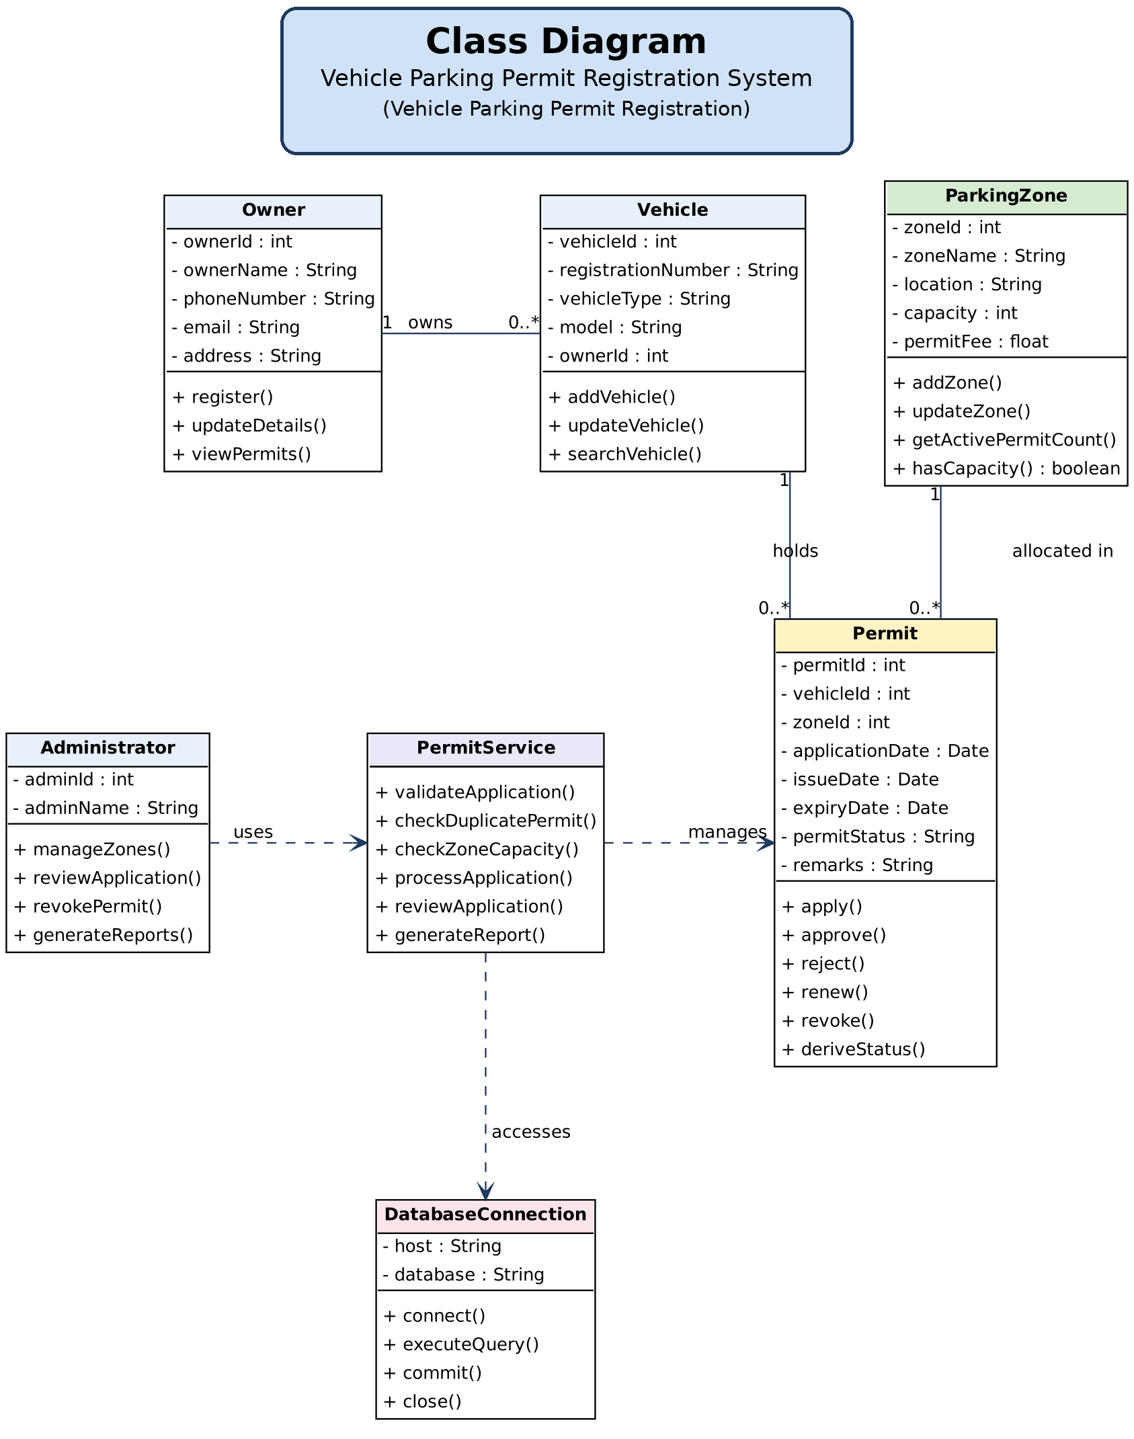

5. State Diagram
The permit moves from Pending to Active when approved, or to Rejected when refused. An Active permit becomes Expired once its expiry date has passed, or Revoked if the administrator cancels it. Expired or Rejected permits can return to Pending through a new or renewal application.
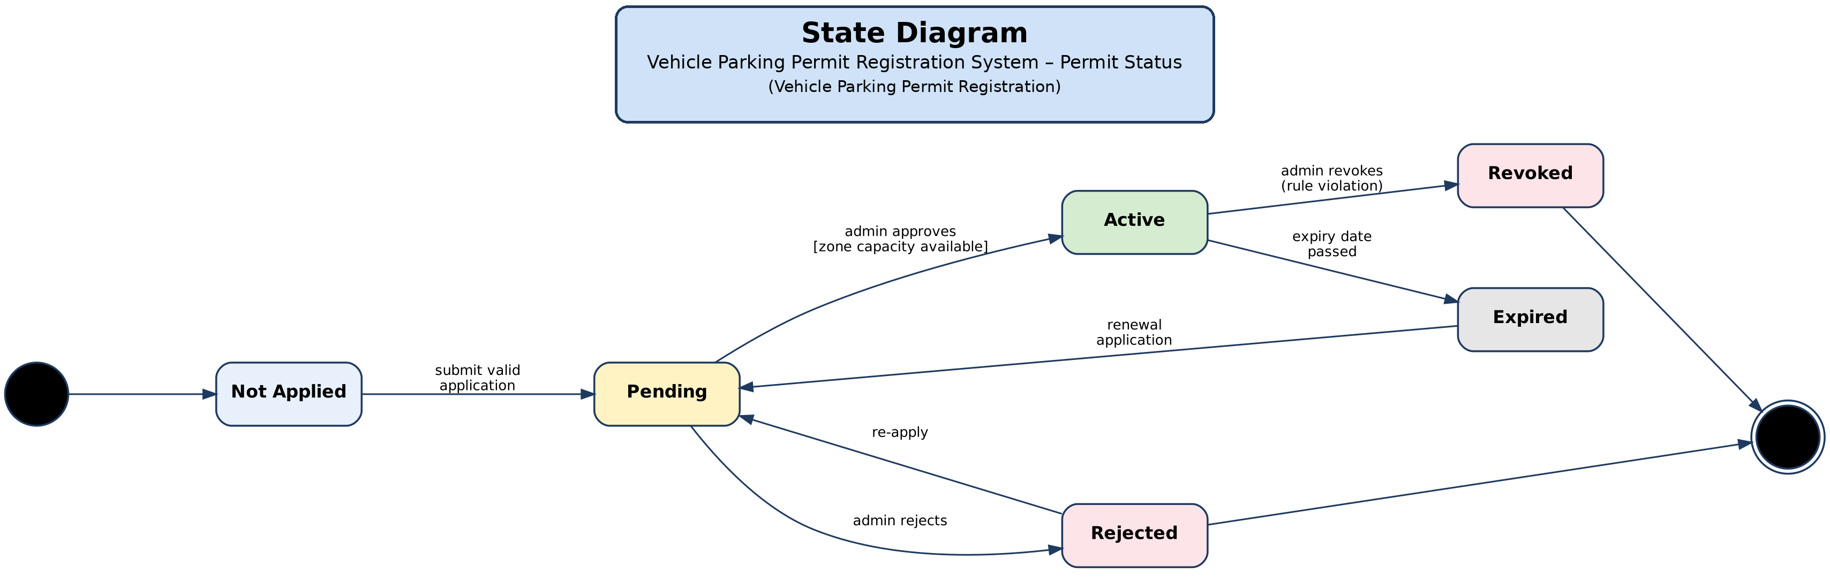

4.4 Data Flow Diagrams
Data Flow Diagrams represent how information moves through the system.
The Level 0 DFD provides an overall view of the system and its interaction with the vehicle owner and the parking administrator.
The Level 1 DFD divides the system into major processes such as managing owners and vehicles, processing permit applications, reviewing and issuing permits, managing parking zones and generating reports.
The Level 2 DFD provides a more detailed view of application processing and review. It covers Process 2.0, Permit Application: receiving the application or renewal request, validating the vehicle and owner, checking for an active permit and zone capacity, finding the previous permit for a renewal, recording the accepted application and returning the result to the applicant.

1. Level 0 Diagram
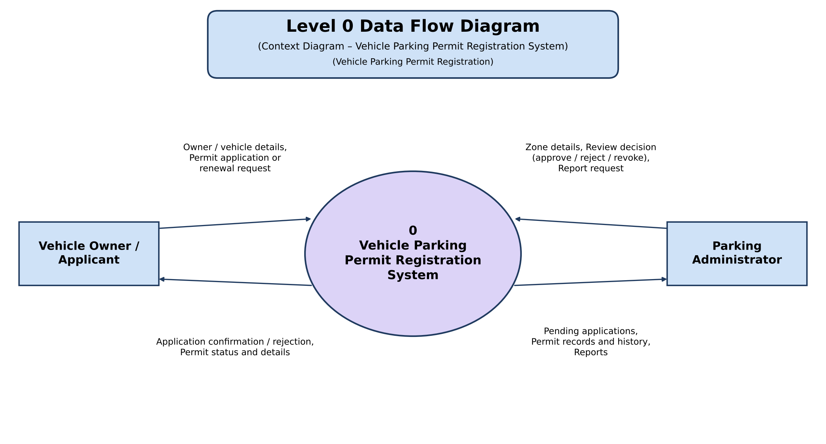

2. Level 1 Diagram
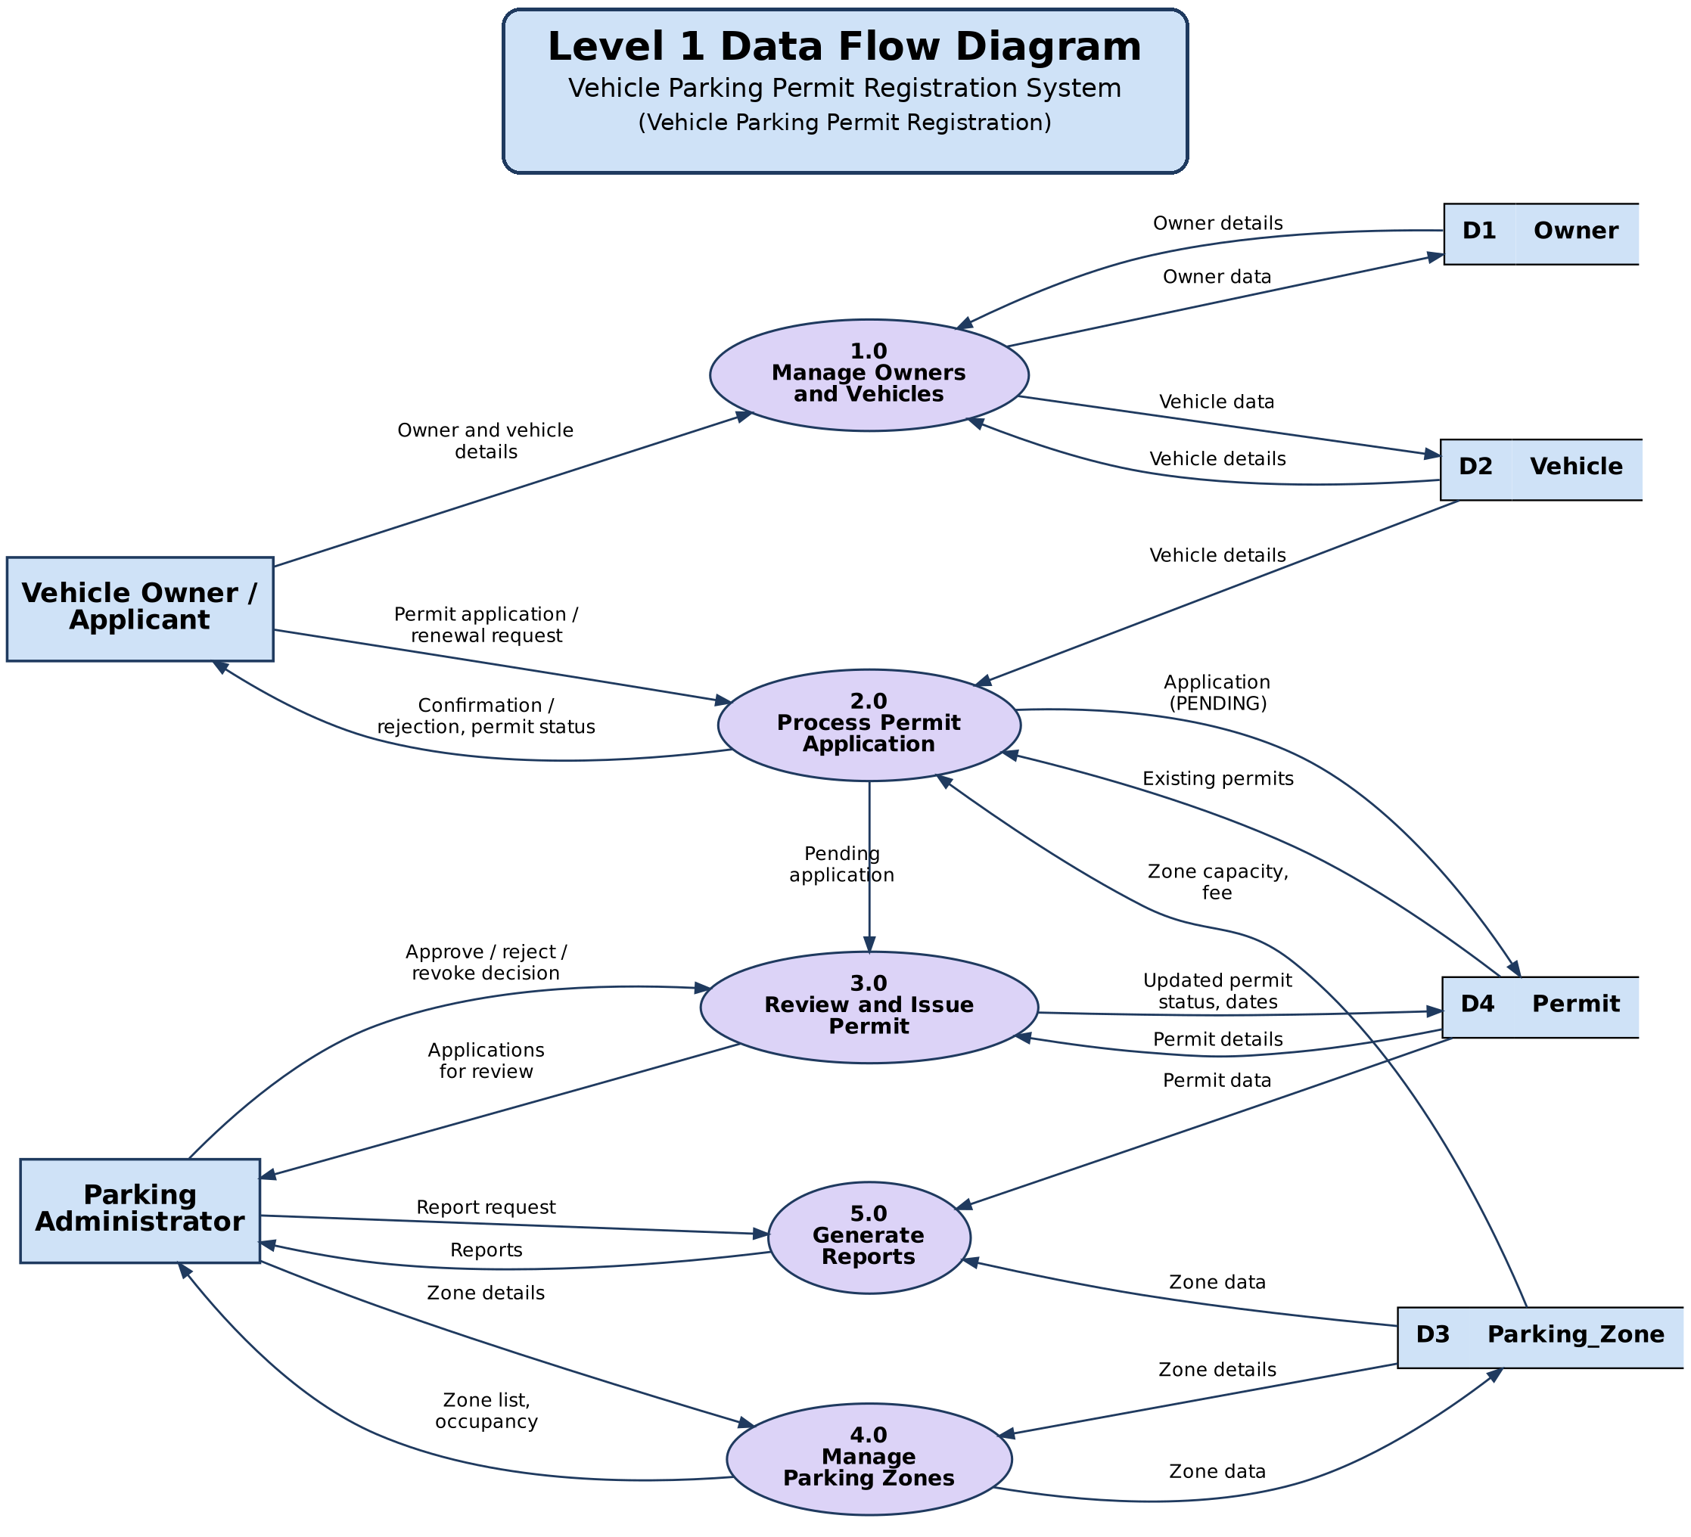

3. Level 2 Diagram
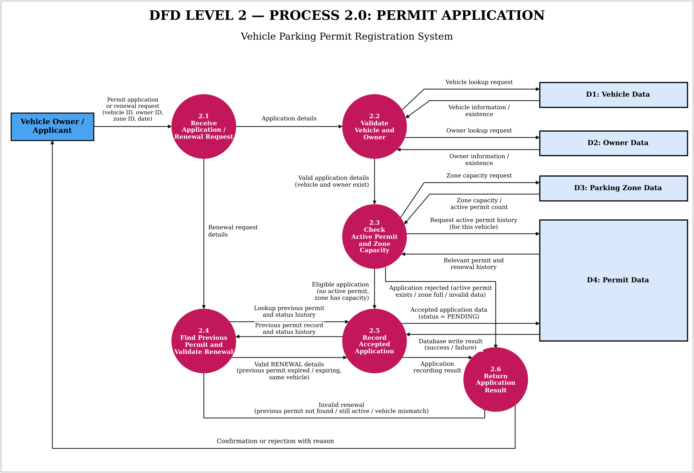

5. Future Enhancement
The current project focuses on registering vehicles and managing parking permits. The system can be improved in the future by adding the following features:
- Role-Based Access: Different access permissions can be provided to the owner, administrator and security staff to improve security.
- Online Payment: Permit fees can be paid online and receipts generated automatically.
- QR Code Permits: A QR code can be printed on each permit so that security staff can verify it quickly at the gate.
- Number Plate Recognition: Cameras can read vehicle number plates and check them against active permits automatically.
- Notifications: Email or SMS reminders can be sent before a permit expires and when an application is approved or rejected.
- Advanced Search and Reports: More search options and detailed reports can be added to make it easier to monitor permits and zone occupancy.
These features are not included in the current project. They may be added in future versions of the system.

6. Conclusion
The Vehicle Parking Permit Registration system aims to provide a structured and reliable method for registering vehicles, issuing parking permits and keeping track of their validity. It replaces manual registers with a web-based system that validates every application, prevents duplicate permits and over-allocation of parking zones, and shows the current status of each permit.
The project applies the foundational concepts of DBMS, Data Structures and Programming, OOP, Web Technologies, and Software Engineering and SDLC. The proposed system will be developed using Python, Flask and MySQL, with testing and validation carried out to check its correctness and consistency.

7. References
- Python Software Foundation. Python Documentation. https://docs.python.org/3/
- Pallets Projects. Flask Documentation. https://flask.palletsprojects.com/en/stable/
- Oracle. MySQL Reference Manual. https://dev.mysql.com/doc/refman/8.0/en/
- Oracle. MySQL Connector/Python Developer Guide. https://dev.mysql.com/doc/connector-python/en/
- Microsoft. Visual Studio Code Documentation. https://code.visualstudio.com/docs
- Course materials for Database Management Systems (DBMS), Data Structures and Algorithms (DSA), Web Technologies, Object-Oriented Programming (OOP), Software Engineering and Software Testing.
- BCA Mini Project Framework and Gate Assessment Guidelines provided by the department.

